ELI Technical Documents
for Certification

Second Edition
2008-05-01

General Application Form
for Product Certification

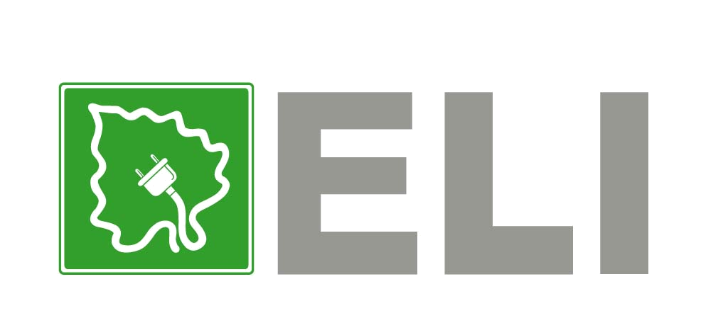
Document No.: ELI/RG01-01

ELI Quality Certification Institute
© IFC 2008

Guidelines to Complete General Application Form

- Fill in the General Application Form with pen or print it with computer (do not use pencil); the handwriting should be legible and clear.
- Name of the applicant and its authorized representative should be consistent with those on corresponding business licenses.
- Give a complete address for the applicant and manufacturer, including country, province/state and city.
- Contact person refers to the authorized representative who is responsible to the certification issues.
- Applicants shall submit this form to ELI Quality Certification Institute both in electronic and in written formats. The written form shall be signed by an authorized officer of the applicant. The applicant should print the signatory’s name and title beneath the signature, as indicated on the signature page and also initial each page (including the annexes).

ELI Quality Certification Institute
Address：
No.33 Zengguang Road, Haidian District, Beijing P.R. China.
Post Code：100048
Tel：8610-88411888-729
Fax：8610- 6843 7171
Website：http://www.efficientlighting.net

ELI Quality Certification Institute:

We would like to apply to the ELI Quality Certification Institute (hereinafter referred to as “ELI Institute”) for ELI Certifications.

We accept the following terms and conditions for ELI Certifications:

1. We have obtained all public documents for ELI Certification, understood the rules and procedures, and agreed to follow the certification protocol;
2. We have made all necessary measures to assure the product qualities, which have been incorporated into our Quality Management System;
3. We will make payment for any fees arising from testing, assessment, ELI log usage and other services related to applied products;
4. If we obtain the ELI qualification, we will comply with the terms specified in ELI agreement signed by both parties and accept the ELI Institute’s monitoring and verification of qualified products.

Here we apply for the ELI Certification for the following products:
Type of Lighting Product for Certification: ; (e.g. CFL, LED, Double-Capped FL)

Product Models for Certification (List of product models included in the Application Package):
Model | Manufacturer | Registered Trademark | Rated Lifetime（h） | Rated Power（W） | Rated Lumen(lm） | Correlated Color  Temperature (K) | Lamp Diameter (mm) | Lamp Shape | Lamp-cap Type | with or without an cover

By:
Authorized Representative

Signature:

Applicant:

The Applicant Information

Applicant | Name
Applicant | Address
Authorized Representative of Applicant
Contact Person
Department |  | Telephone
Fax |  | E-mail*

Manufacturing Plant Information

Manufacturer | Name
Manufacturer | Address
Total number of manufacturer’s staff |  | Total number of manufacturer’s technical staff
Contact Person
Department |  | Telephone
Fax |  | E-mail

Note: If product models covered by this General Application Form are from more than one manufacturing plant, the applicant shall provide details of additional manufacturing plants using separate copies of the table above.
- List of Key Manufacturing Equipments

No. | Name | Model | Place of Manufacturing | Quantity

2．Production Process Flow Chart

3. Testing Capacity

Overview of Inspection/Testing Capacity
Technical staff | Number of Technical staff:
Laboratory Accreditation

4．Main Testing Equipments and Instruments

No. | Name | Model/  Specification | Usage | Manufacturer | Quantity | Calibration Executed

